Composite Path

Definition
# Source: AI Source: Provided by: [Data Path: Persons Table -> ID Column: 1, Name_En Column: Motasem Essam] -> From: [ChatGPT] on [7/25/2026]
A Composite Path is a geometric path formed by combining two or more different path pieces or geometric path types into one overall path.
The individual pieces may be:
- straight-line segments
- circular arcs
- other curves
- polygonal sections
- parametric curves
- or combinations of these.
Mathematically:
$$\boxed{P=P_{1}∪P_{2}∪⋯∪P_{n}, n≥2}$$
where each $P_{i}$represents one component of the overall path.
Simple Definition
A Composite Path is a path made by joining two or more different path pieces into one path.

Main Classification
# Source: AI Source: Provided by: [Data Path: Persons Table -> ID Column: 1, Name_En Column: Motasem Essam] -> From: [ChatGPT] on [7/25/2026]
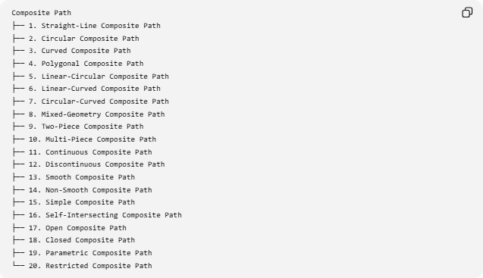
Composite Path
├── 1. Straight-Line Composite Path
├── 2. Circular Composite Path
├── 3. Curved Composite Path
├── 4. Polygonal Composite Path
├── 5. Linear-Circular Composite Path
├── 6. Linear-Curved Composite Path
├── 7. Circular-Curved Composite Path
├── 8. Mixed-Geometry Composite Path
├── 9. Two-Piece Composite Path
├── 10. Multi-Piece Composite Path
├── 11. Continuous Composite Path
├── 12. Discontinuous Composite Path
├── 13. Smooth Composite Path
├── 14. Non-Smooth Composite Path
├── 15. Simple Composite Path
├── 16. Self-Intersecting Composite Path
├── 17. Open Composite Path
├── 18. Closed Composite Path
├── 19. Parametric Composite Path
└── 20. Restricted Composite Path

1. Straight-Line Composite Path
# Source: AI Source: Provided by: [Data Path: Persons Table -> ID Column: 1, Name_En Column: Motasem Essam] -> From: [ChatGPT] on [7/25/2026]
A Straight-Line Composite Path consists of multiple straight-line pieces combined into one overall path.
It may contain different directions and lengths.
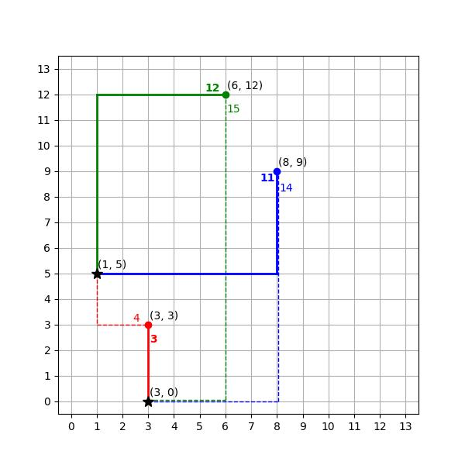
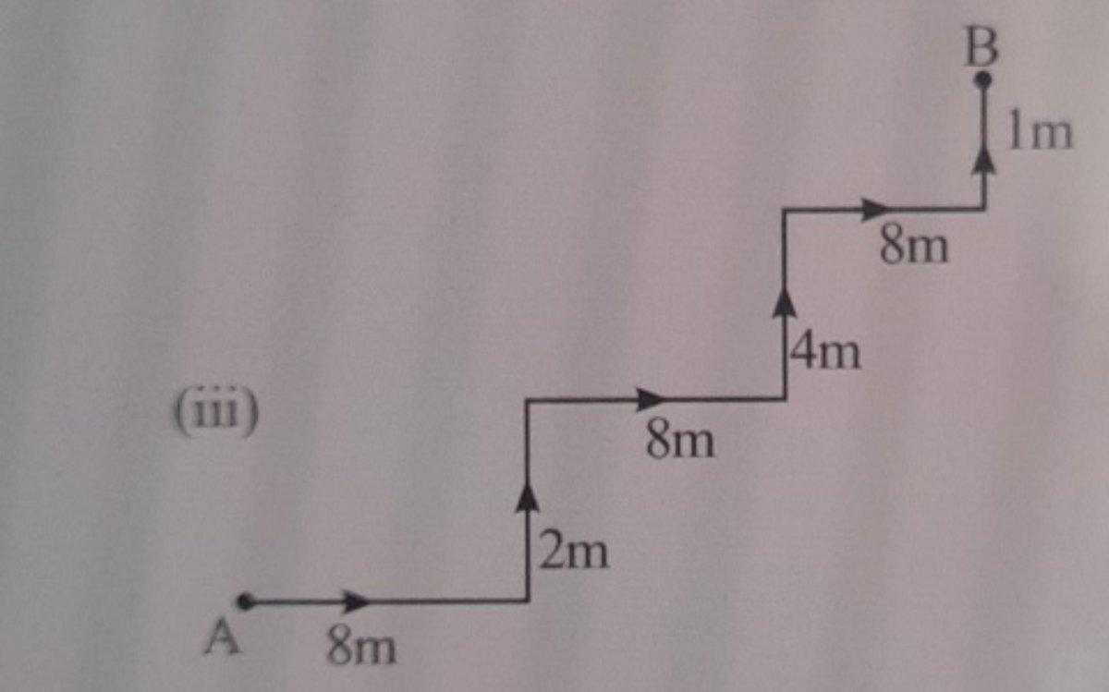
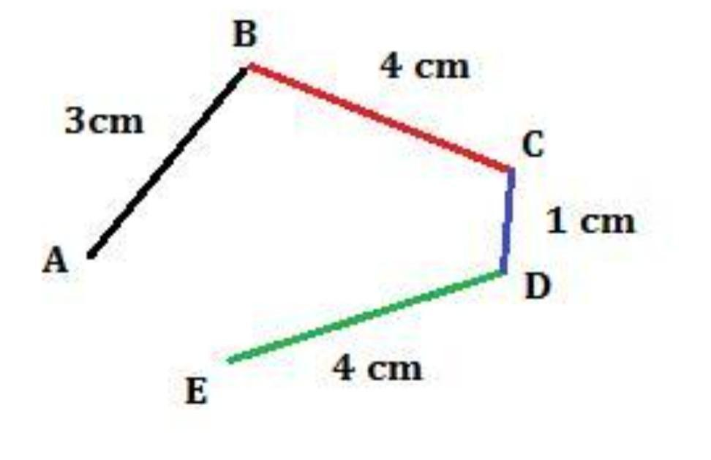
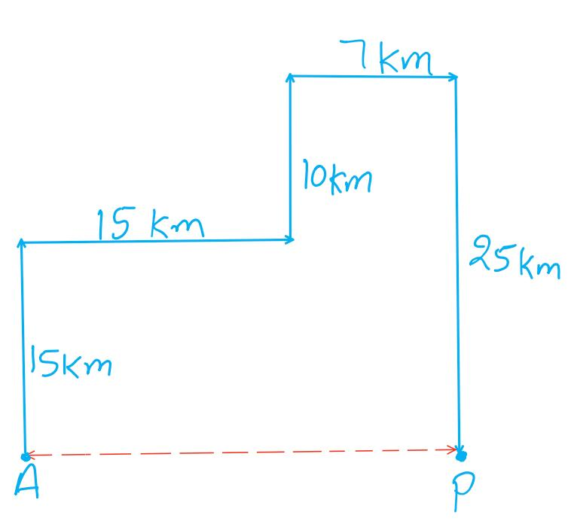
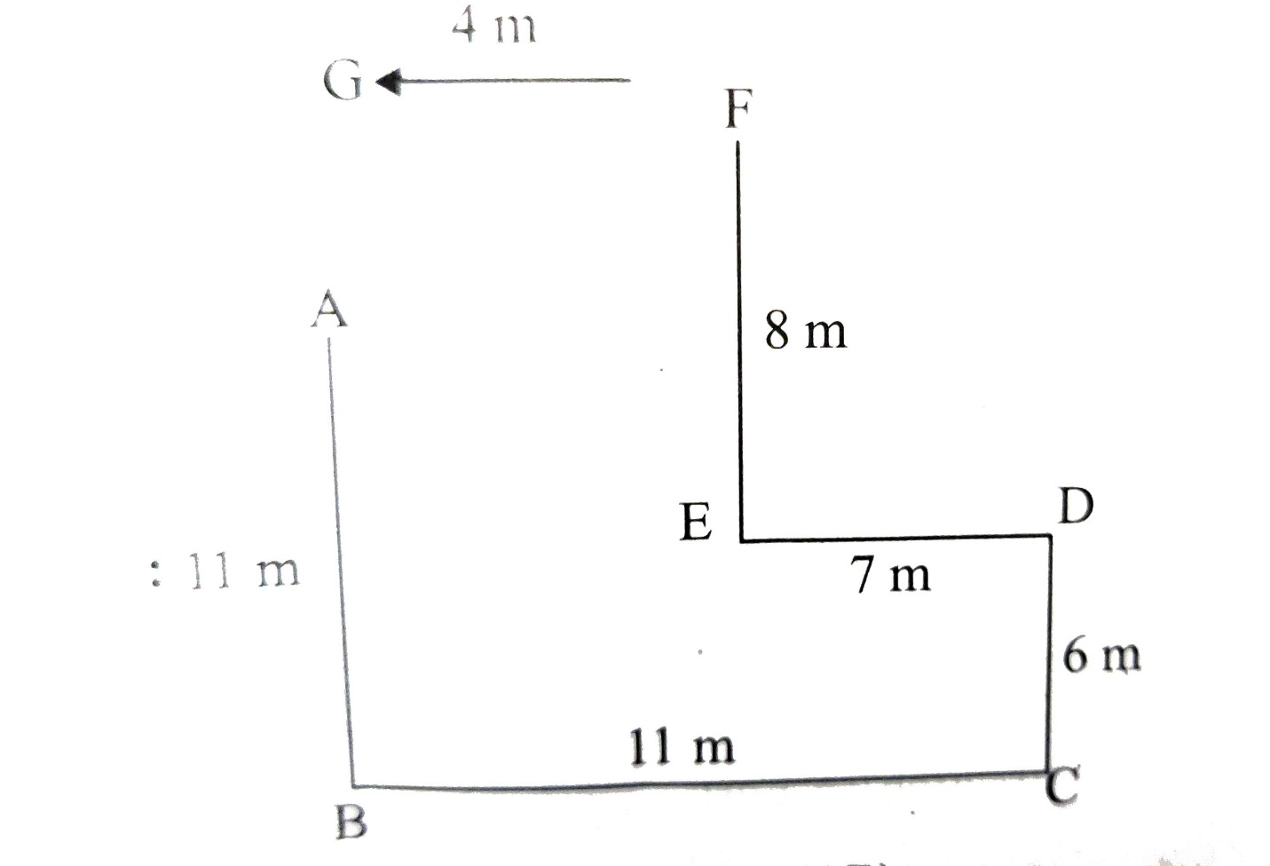
Example
$$A→B→C→D$$
where:
$$AB, BC, CD$$
are all straight-line segments.
A polygonal path is a common example.

2. Circular Composite Path
# Source: AI Source: Provided by: [Data Path: Persons Table -> ID Column: 1, Name_En Column: Motasem Essam] -> From: [ChatGPT] on [7/25/2026]
A Circular Composite Path consists of two or more circular path pieces, usually circular arcs.
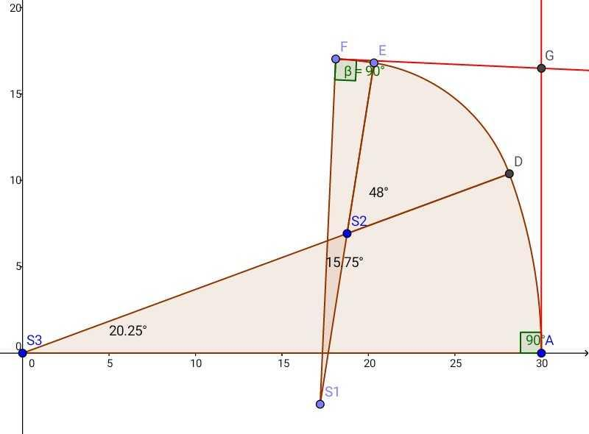
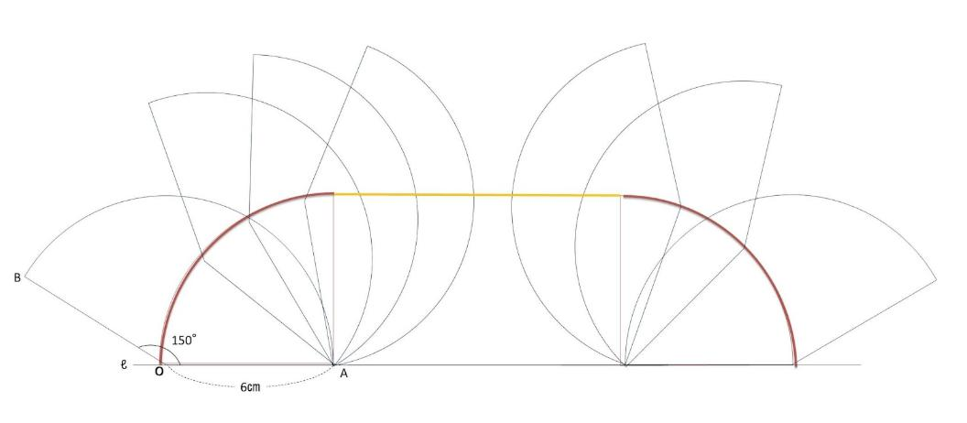
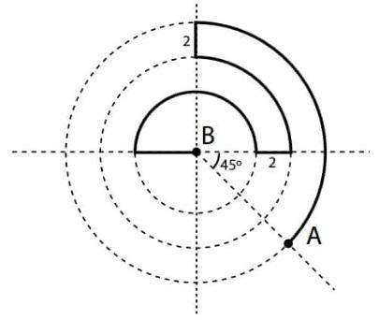
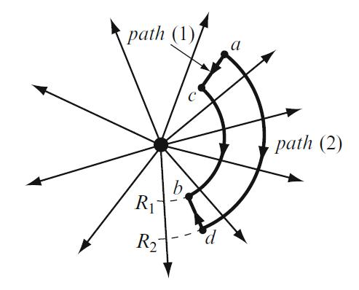
Example
$${\text{Arc}}_{1}→{\text{Arc}}_{2}→{\text{Arc}}_{3}$$
The arcs may have:
- different centers
- different radii
- different angular ranges.
For each circular arc:
$$\boxed{s=rθ}$$
and the total length is:
$$\boxed{L=s_{1}+s_{2}+⋯+s_{n}}$$

3. Curved Composite Path
# Source: AI Source: Provided by: [Data Path: Persons Table -> ID Column: 1, Name_En Column: Motasem Essam] -> From: [ChatGPT] on [7/25/2026]
A Curved Composite Path consists of multiple curved pieces joined together.
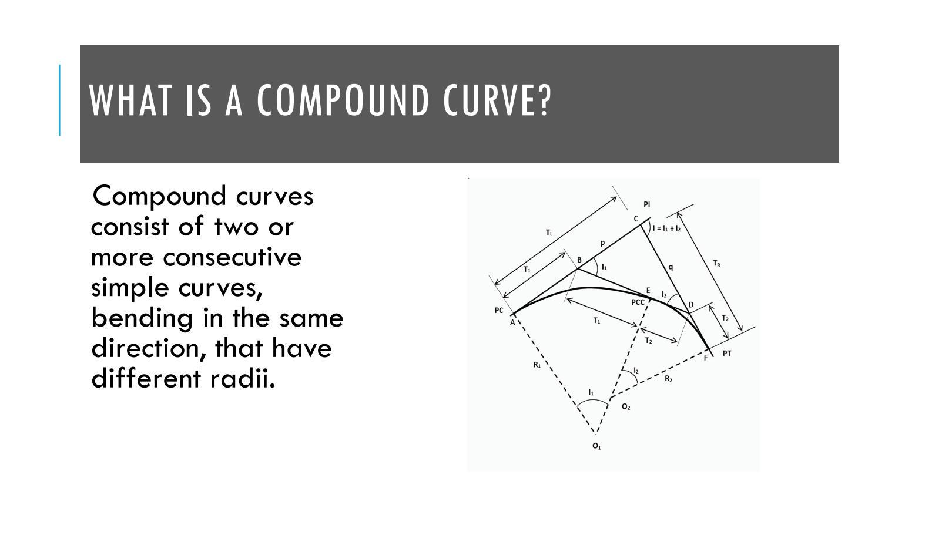
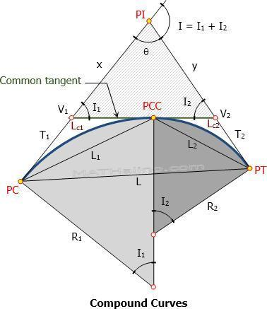
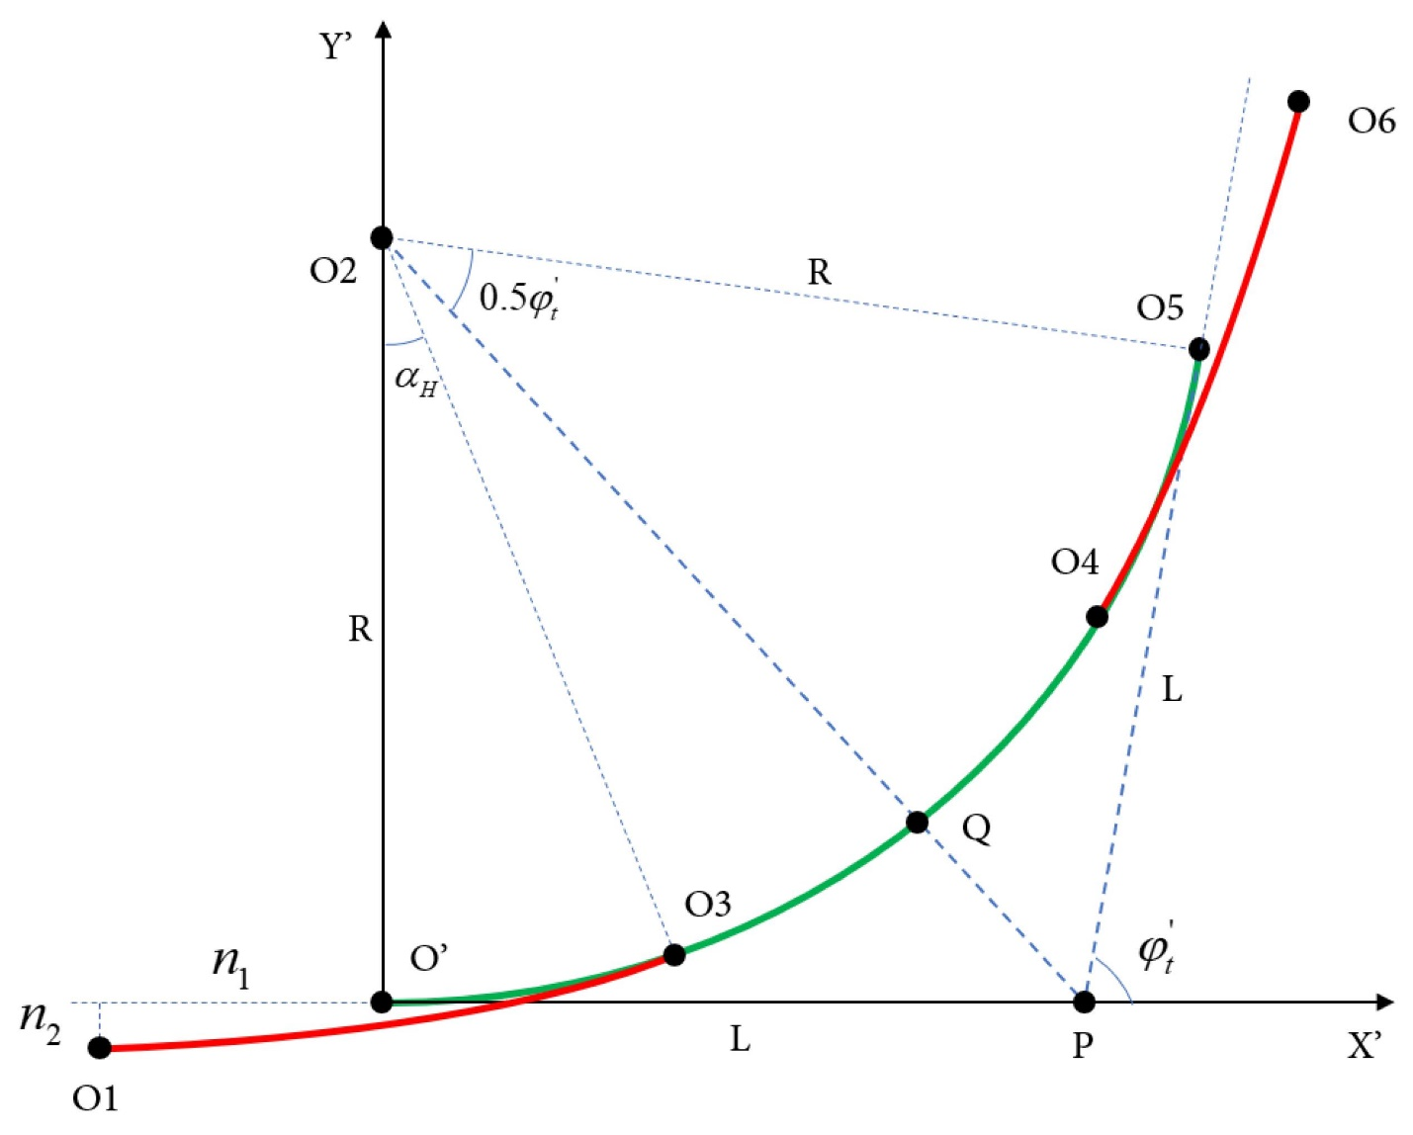
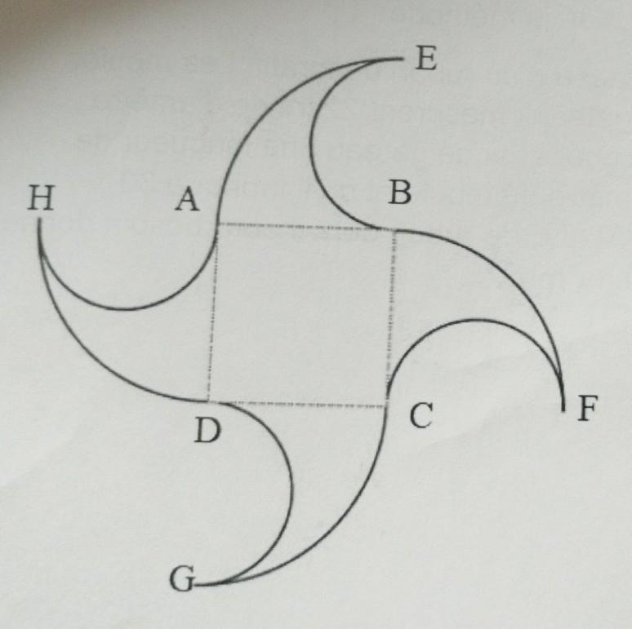
Example
$$\text{Parabolic Arc}→\text{Elliptical Arc}→\text{Circular Arc}$$
Each piece follows a different curved rule.

4. Polygonal Composite Path
# Source: AI Source: Provided by: [Data Path: Persons Table -> ID Column: 1, Name_En Column: Motasem Essam] -> From: [ChatGPT] on [7/25/2026]
A Polygonal Composite Path consists of multiple polygonal sections joined together.
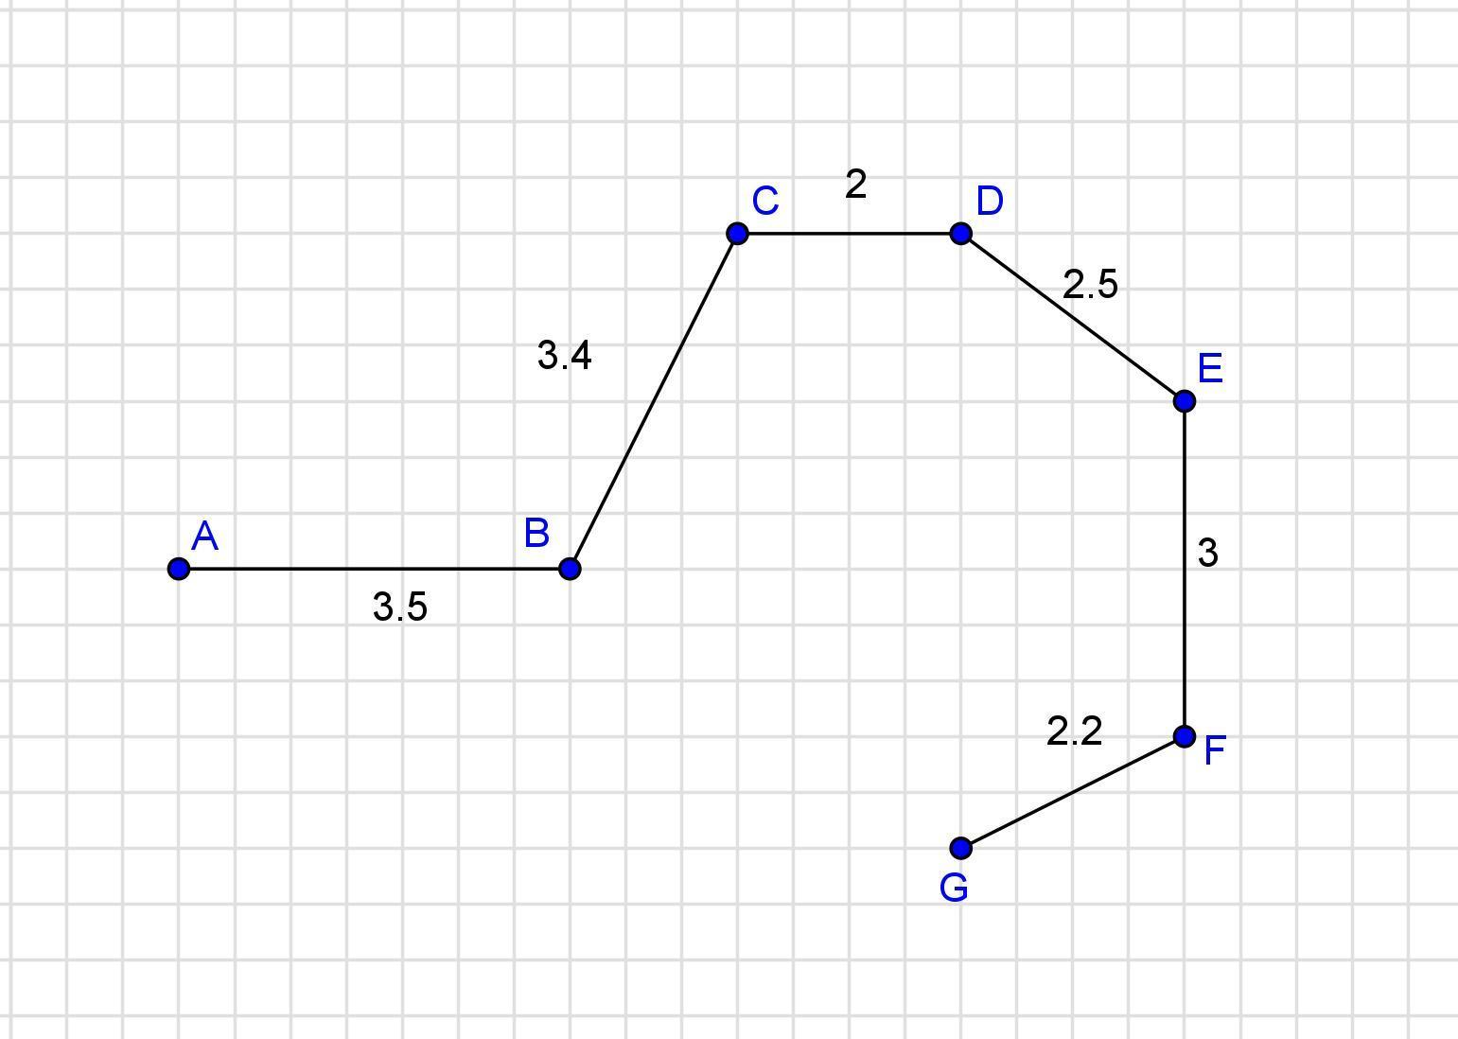
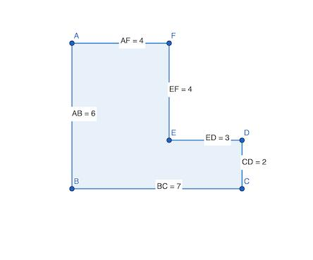
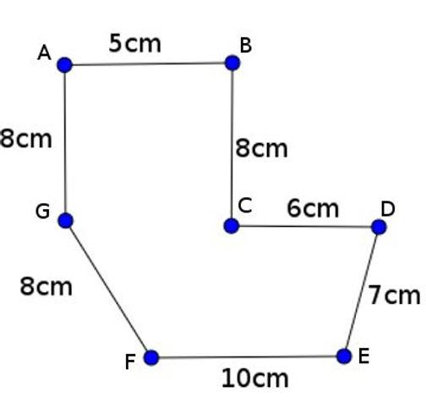
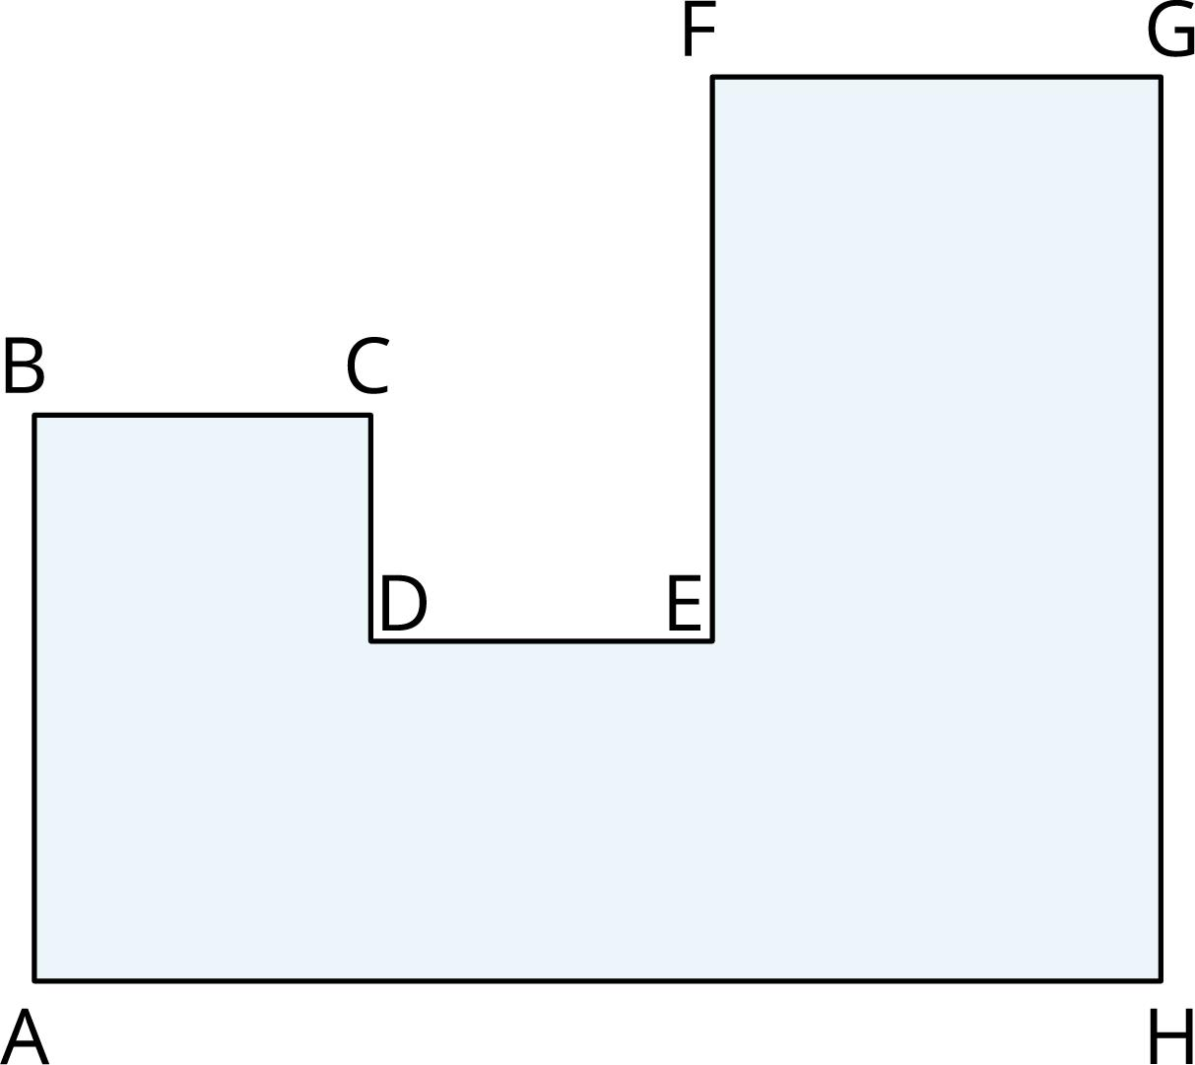
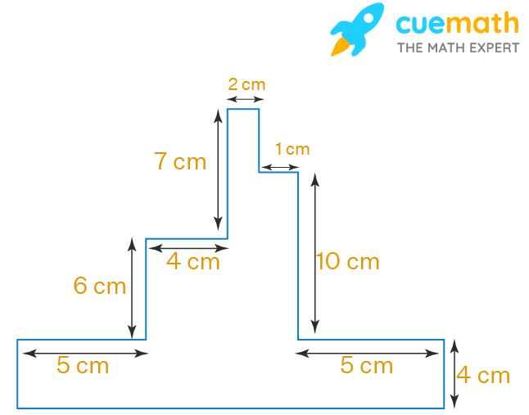
Example
A path can contain:
$$\text{Triangle-like section}→\text{Quadrilateral-like section}→\text{Triangle-like section}.$$
Each section consists of straight-line segments.

5. Linear-Circular Composite Path
# Source: AI Source: Provided by: [Data Path: Persons Table -> ID Column: 1, Name_En Column: Motasem Essam] -> From: [ChatGPT] on [7/25/2026]
A Linear-Circular Composite Path combines straight-line segments with circular arcs.
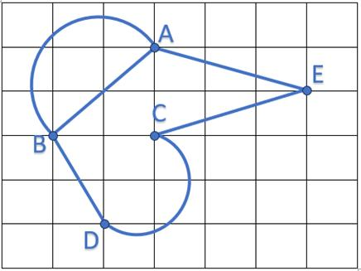
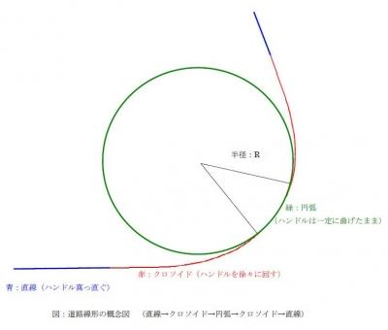
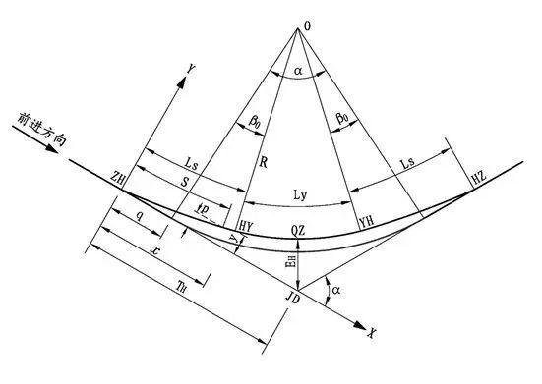
A common structure is:
$$\boxed{\text{Straight}→\text{Circular Arc}→\text{Straight}}$$
Example
A road can have:
- a straight section,
- a circular turn,
- another straight section.
This type is important in:
- road design
- railway design
- robotics
- vehicle path planning.

6. Linear-Curved Composite Path
# Source: AI Source: Provided by: [Data Path: Persons Table -> ID Column: 1, Name_En Column: Motasem Essam] -> From: [ChatGPT] on [7/25/2026]
A Linear-Curved Composite Path combines straight segments with general curved pieces.
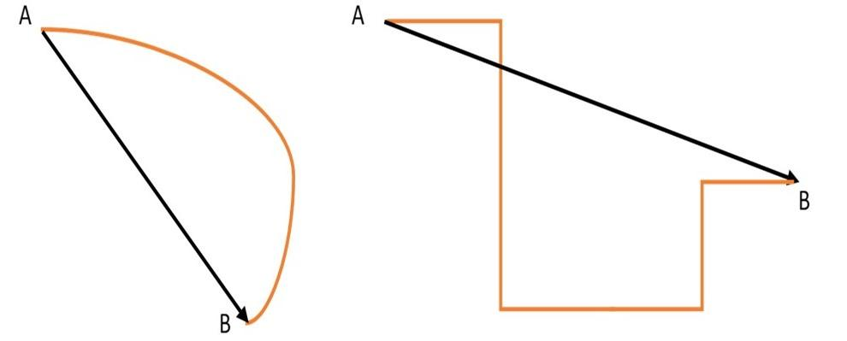
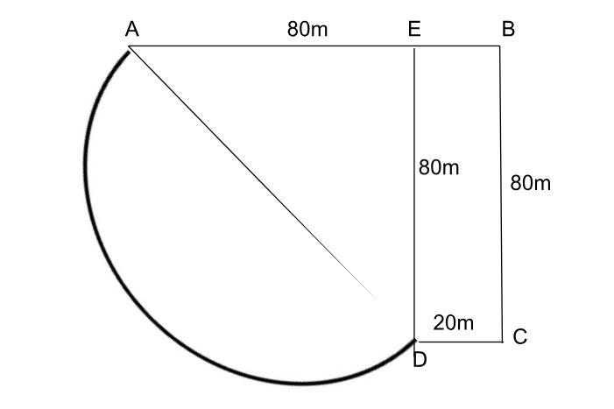
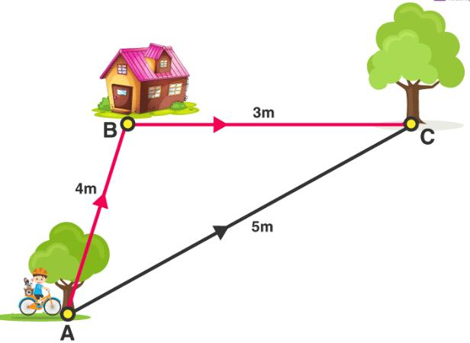
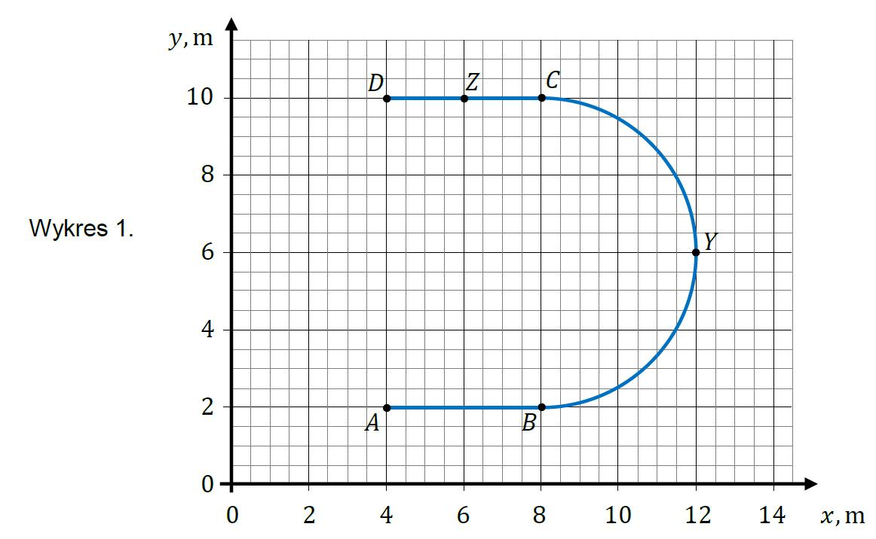
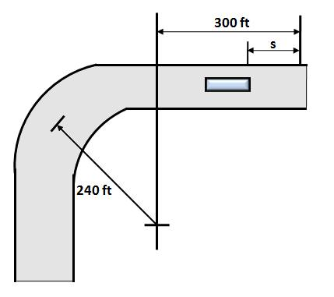
Example
$$\text{Line}→\text{Parabolic Arc}→\text{Line}$$
The curved portion does not have to be circular.

7. Circular-Curved Composite Path
# Source: AI Source: Provided by: [Data Path: Persons Table -> ID Column: 1, Name_En Column: Motasem Essam] -> From: [ChatGPT] on [7/25/2026]
A Circular-Curved Composite Path combines circular arcs with other curved pieces.
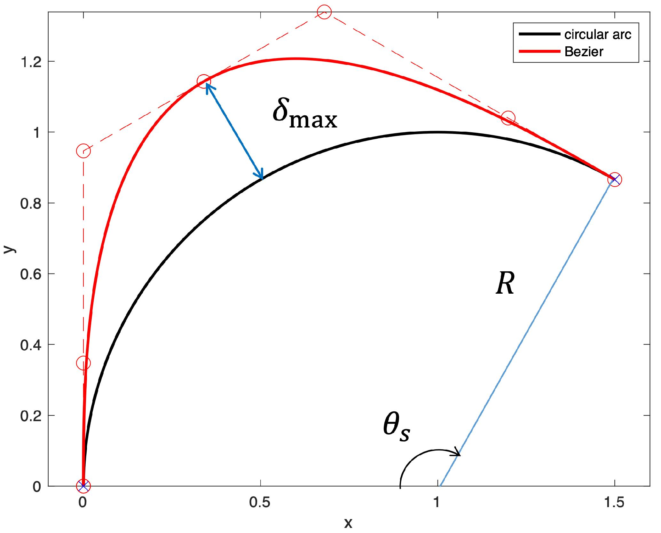
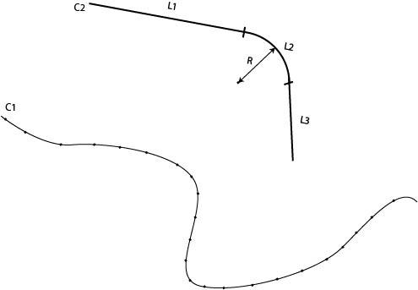
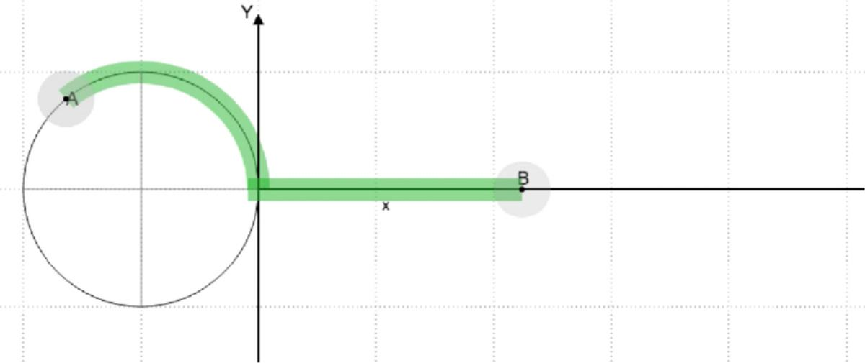
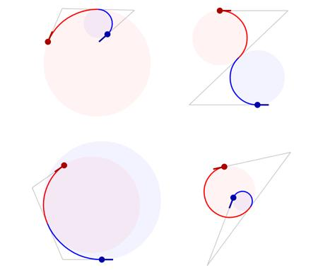
Example
$$\text{Circular Arc}→\text{Parabolic Arc}→\text{Circular Arc}$$

8. Mixed-Geometry Composite Path
# Source: AI Source: Provided by: [Data Path: Persons Table -> ID Column: 1, Name_En Column: Motasem Essam] -> From: [ChatGPT] on [7/25/2026]
A Mixed-Geometry Composite Path combines several different geometric path types.
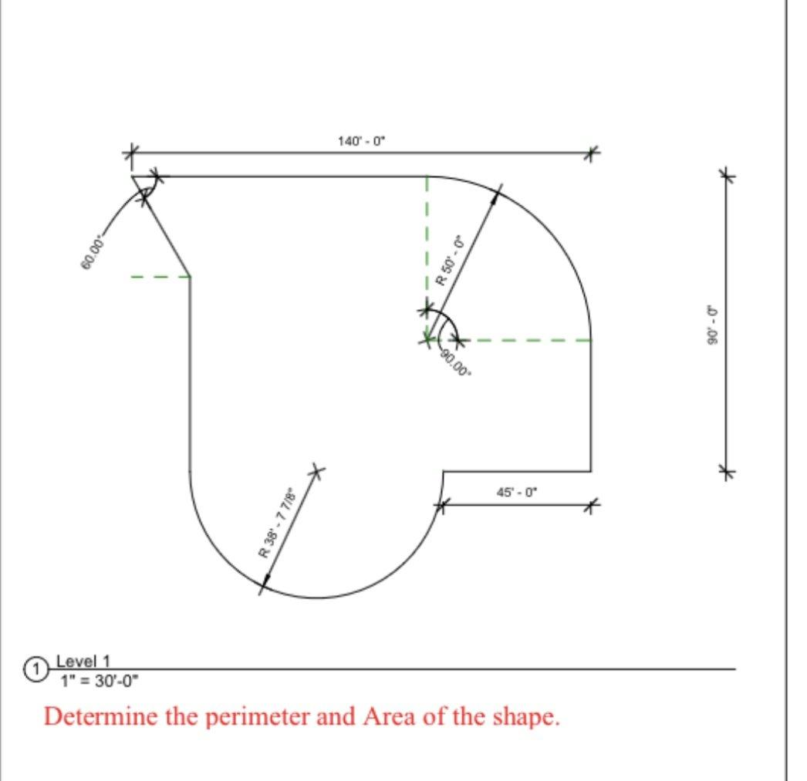
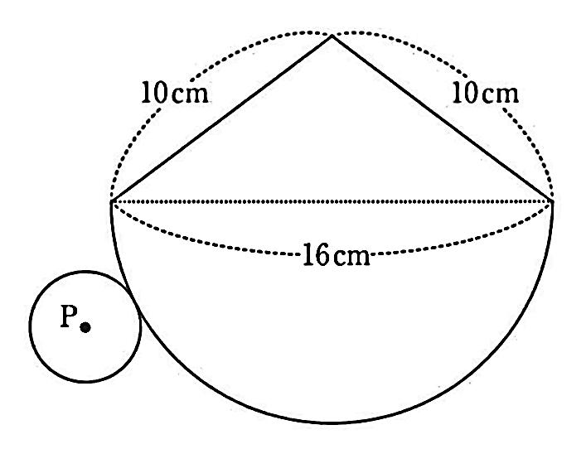
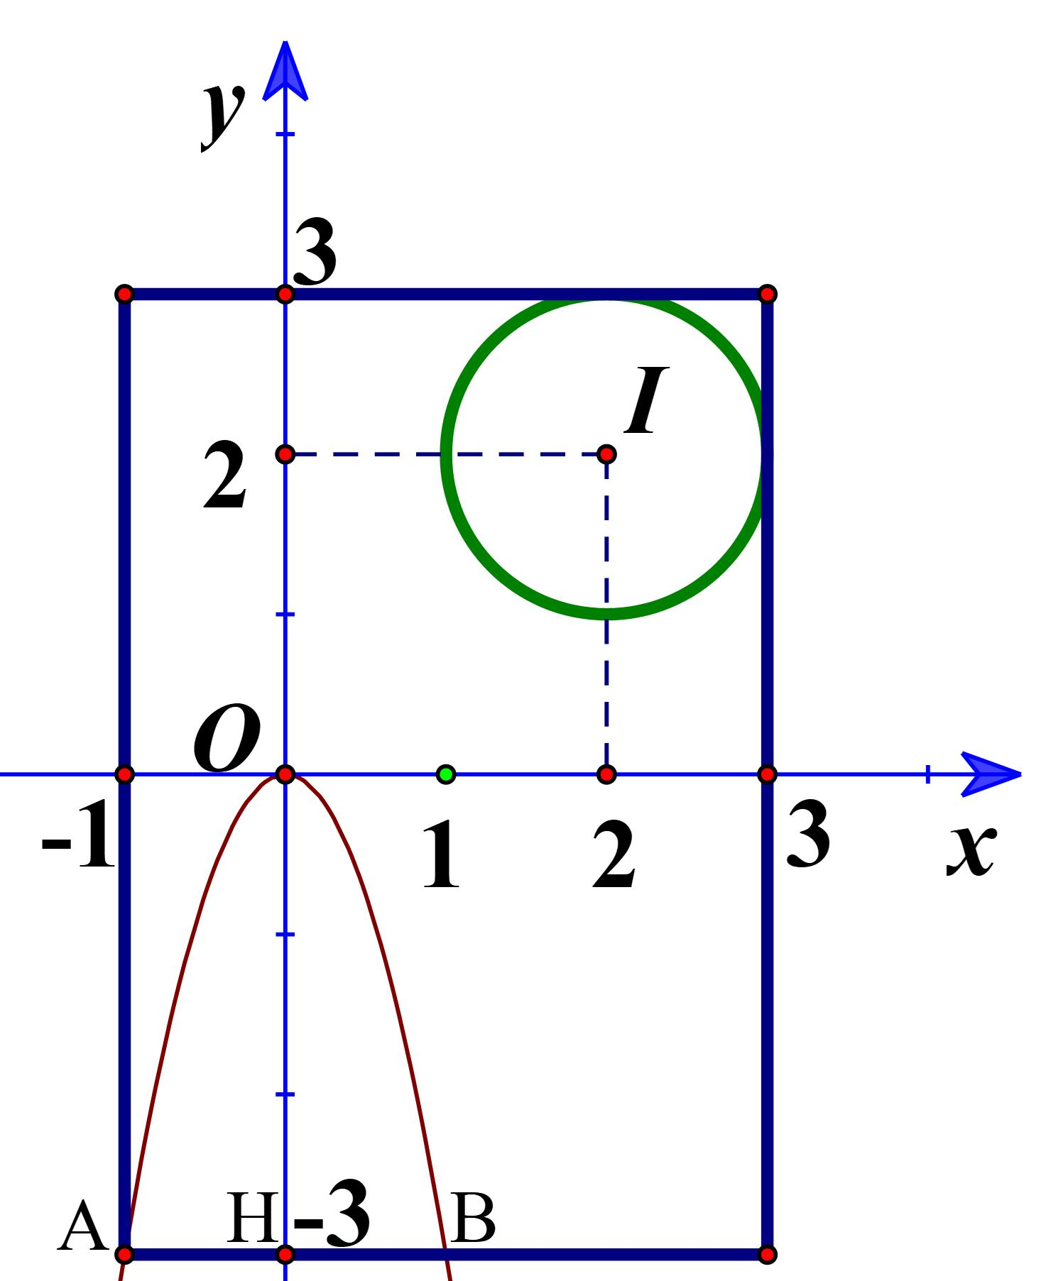
Example
$$\boxed{\text{Straight}→\text{Circular}→\text{Parabolic}→\text{Straight}}$$
This is one of the broadest forms of composite path.

9. Two-Piece Composite Path
# Source: AI Source: Provided by: [Data Path: Persons Table -> ID Column: 1, Name_En Column: Motasem Essam] -> From: [ChatGPT] on [7/25/2026]
A Two-Piece Composite Path contains exactly two connected path pieces:
$$\boxed{P=P_{1}∪P_{2}}$$
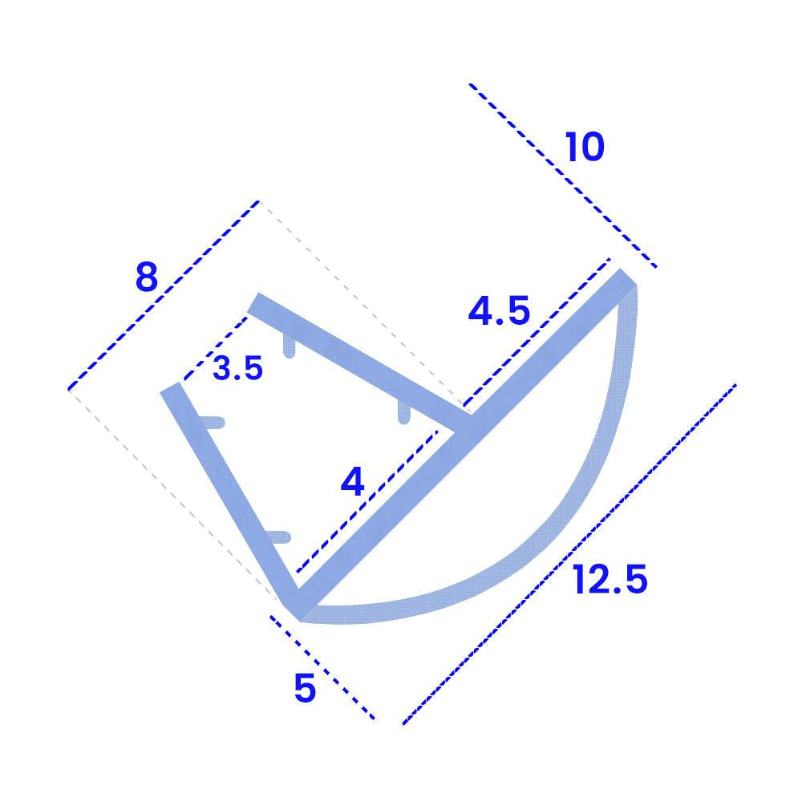
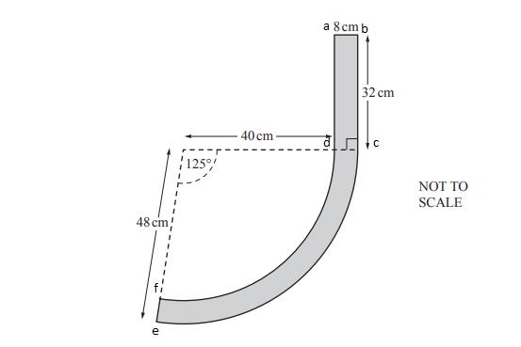
Example
$$\text{Straight Segment}→\text{Circular Arc}$$
The two pieces meet at a common point.

10. Multi-Piece Composite Path
# Source: AI Source: Provided by: [Data Path: Persons Table -> ID Column: 1, Name_En Column: Motasem Essam] -> From: [ChatGPT] on [7/25/2026]
A Multi-Piece Composite Path contains three or more pieces:
$$\boxed{P=P_{1}∪P_{2}∪⋯∪P_{n}, n≥3}$$
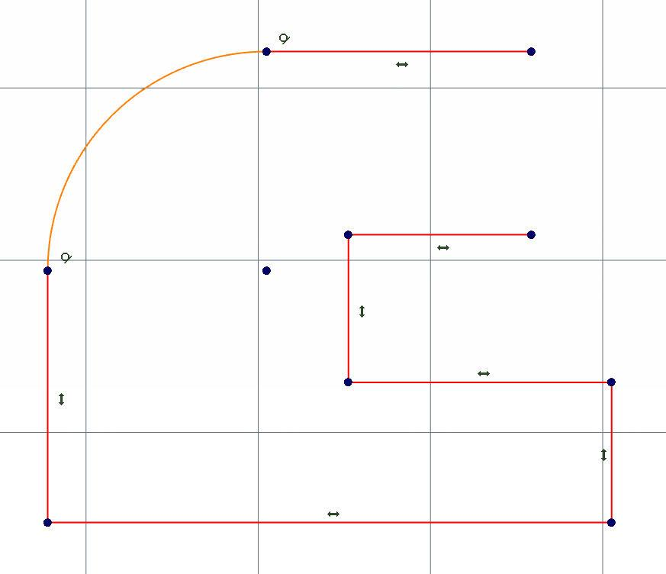
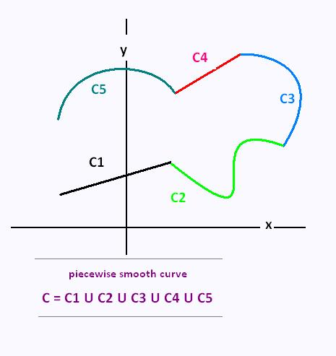
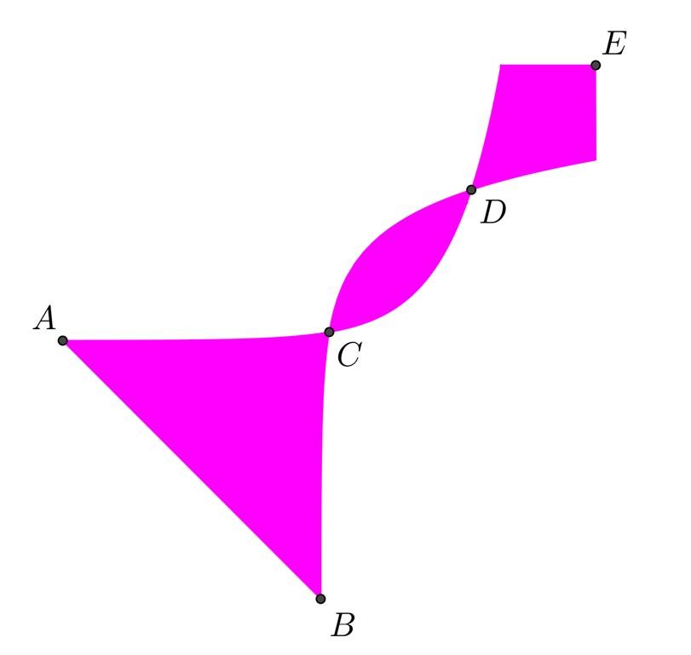
Example
$$\text{Line}→\text{Arc}→\text{Line}→\text{Parabola}→\text{Line}$$

11. Continuous Composite Path
# Source: AI Source: Provided by: [Data Path: Persons Table -> ID Column: 1, Name_En Column: Motasem Essam] -> From: [ChatGPT] on [7/25/2026]
A Continuous Composite Path consists of pieces that connect without gaps.
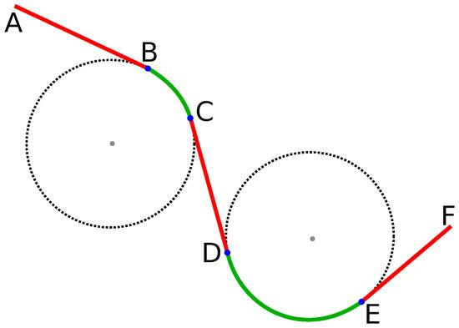
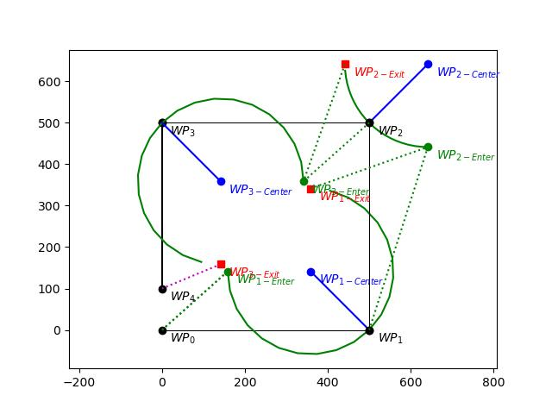
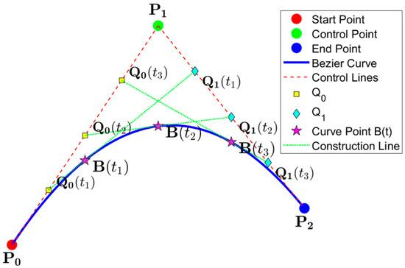
At a junction $V_{i}$:
$$\boxed{P_{i}\left(t_{i}\right)=P_{i+1}\left(t_{i}\right)}$$
Example
A straight segment ending exactly where a circular arc begins is continuous.
Important:
$$\boxed{\text{Continuous does not necessarily mean Smooth}}$$

12. Discontinuous Composite Path
# Source: AI Source: Provided by: [Data Path: Persons Table -> ID Column: 1, Name_En Column: Motasem Essam] -> From: [ChatGPT] on [7/25/2026]
A Discontinuous Composite Path contains a gap or jump between two pieces.
At a transition:
$$\boxed{\lim_{t→t_{0}^{-}}r\left(t\right)≠\lim_{t→t_{0}^{+}}r\left(t\right)}$$
Example
One path piece ends at $A$, while the next begins at a different point $B$:
$$A≠B.$$

13. Smooth Composite Path
# Source: AI Source: Provided by: [Data Path: Persons Table -> ID Column: 1, Name_En Column: Motasem Essam] -> From: [ChatGPT] on [7/25/2026]
A Smooth Composite Path consists of pieces that connect with matching tangent directions.
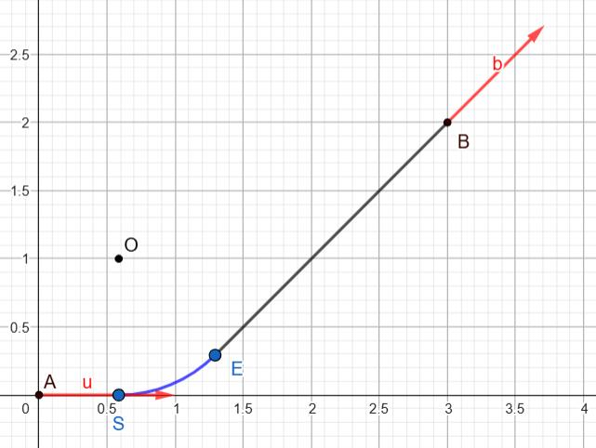
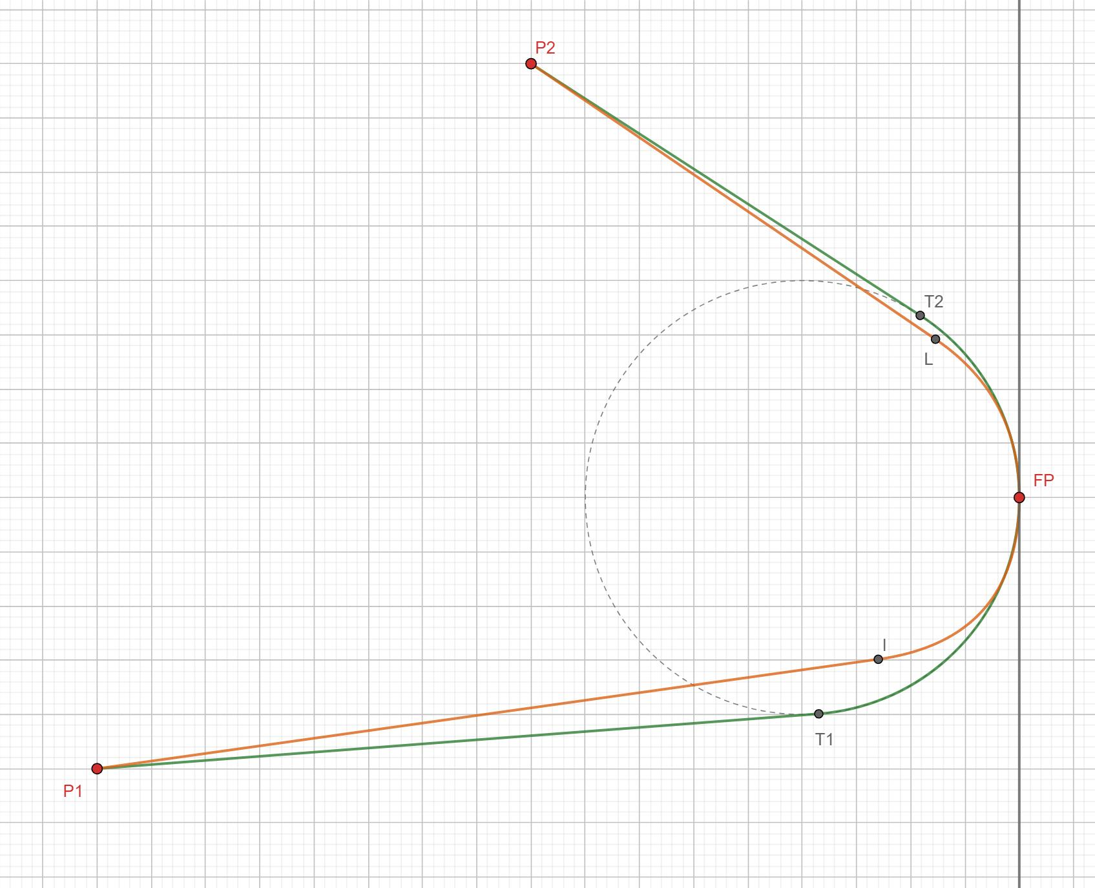
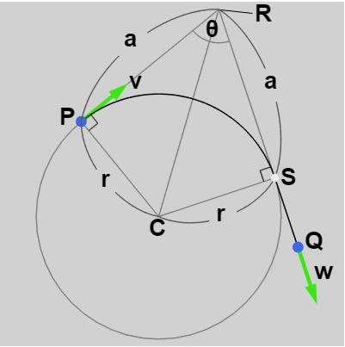
At a junction:
$$\boxed{T_{1}\left(V\right)=T_{2}\left(V\right)}$$
Example
A straight line transitioning into a circular arc can be smooth if the line is tangent to the circle at their joining point.
Thus:
$$\boxed{\text{Smooth Composite Path}⇒\text{Continuous Composite Path}}$$
but:
$$\boxed{\text{Continuous Composite Path}⇏\text{Smooth Composite Path}}$$

14. Non-Smooth Composite Path
# Source: AI Source: Provided by: [Data Path: Persons Table -> ID Column: 1, Name_En Column: Motasem Essam] -> From: [ChatGPT] on [7/25/2026]
A Non-Smooth Composite Path contains at least one junction where the direction changes abruptly.
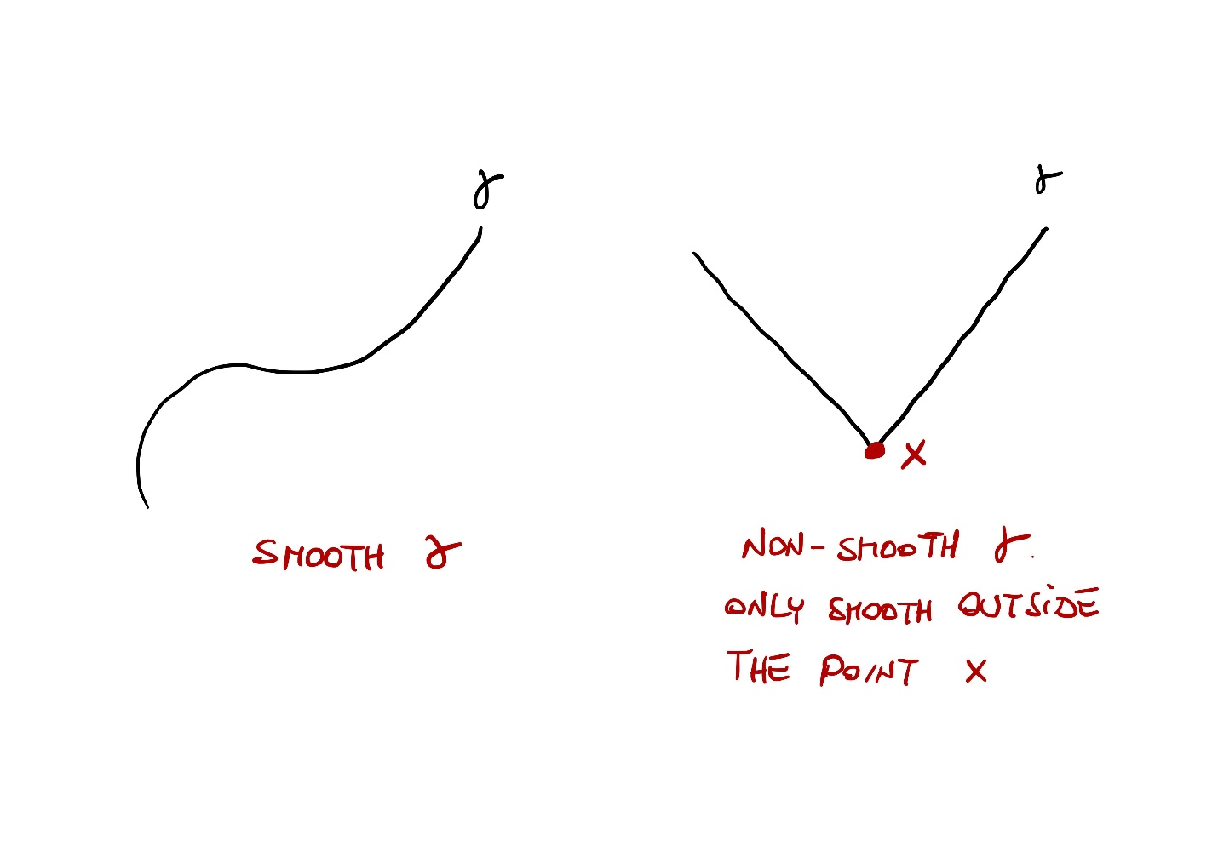
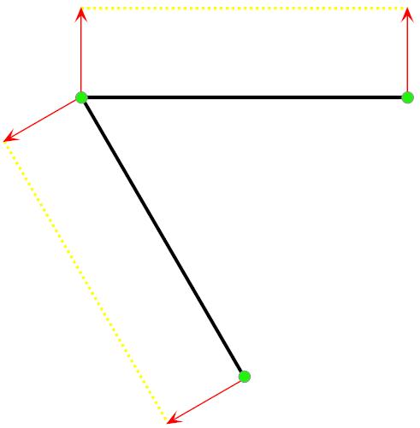
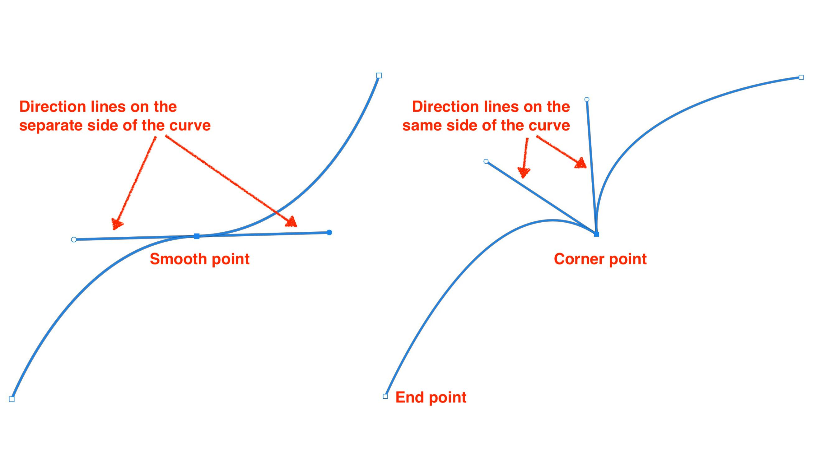
Example
$$\text{Straight Segment}→\text{Straight Segment}$$
meeting at a sharp angle.
The path is continuous but not smooth at the corner.

15. Simple Composite Path
# Source: AI Source: Provided by: [Data Path: Persons Table -> ID Column: 1, Name_En Column: Motasem Essam] -> From: [ChatGPT] on [7/25/2026]
A Simple Composite Path combines multiple path pieces without self-intersection.
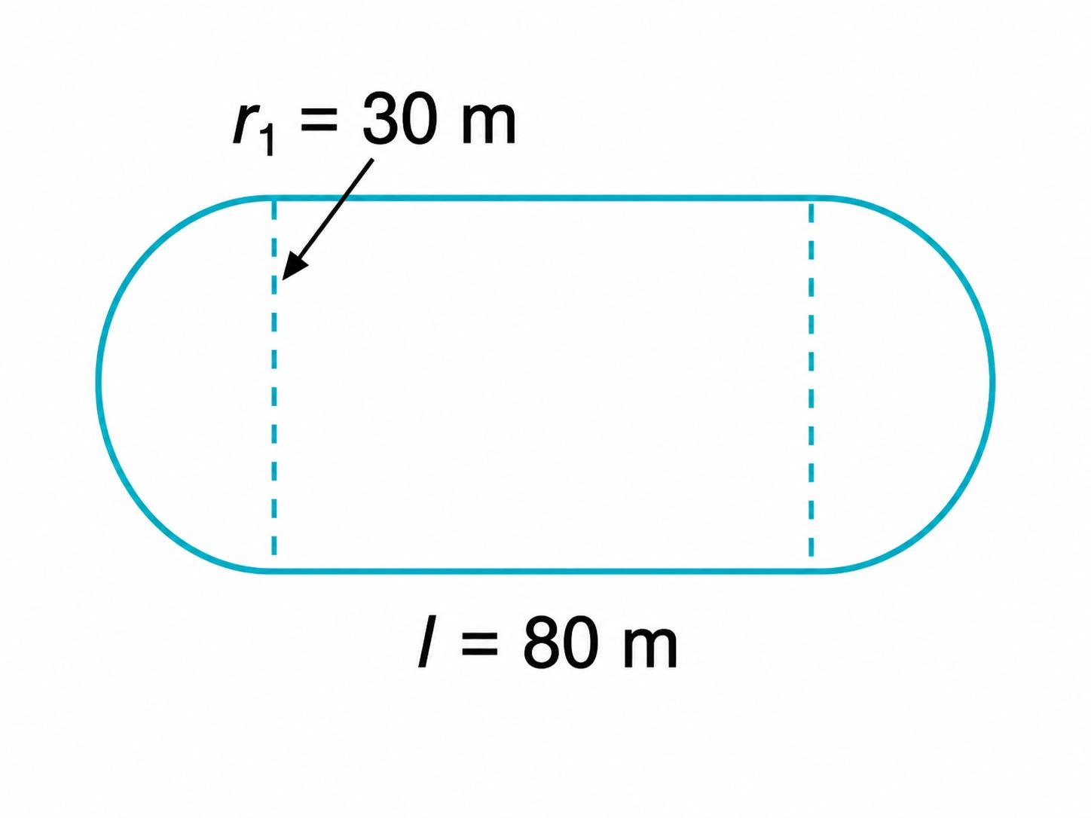
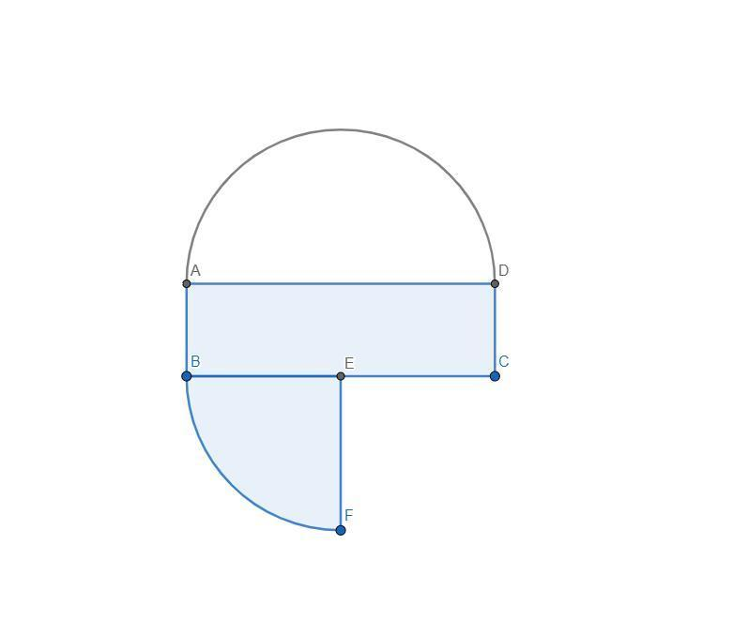
Example
$$\text{Line}→\text{Arc}→\text{Line}$$
with no piece crossing another nonadjacent piece.
Therefore:
$$\boxed{\text{Composite}+\text{No Self-Intersection}=\text{Simple Composite Path}}$$

16. Self-Intersecting Composite Path
# Source: AI Source: Provided by: [Data Path: Persons Table -> ID Column: 1, Name_En Column: Motasem Essam] -> From: [ChatGPT] on [7/25/2026]
A Self-Intersecting Composite Path contains multiple pieces that cross or meet themselves at nonconsecutive portions.
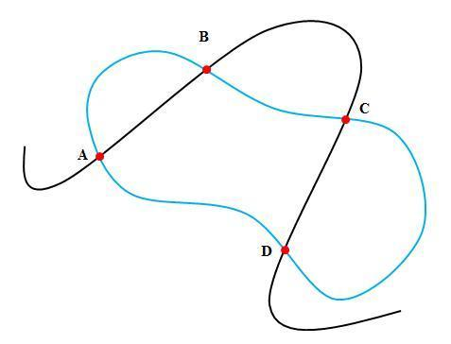
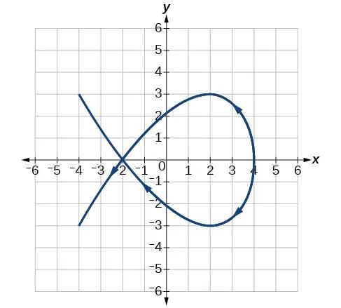
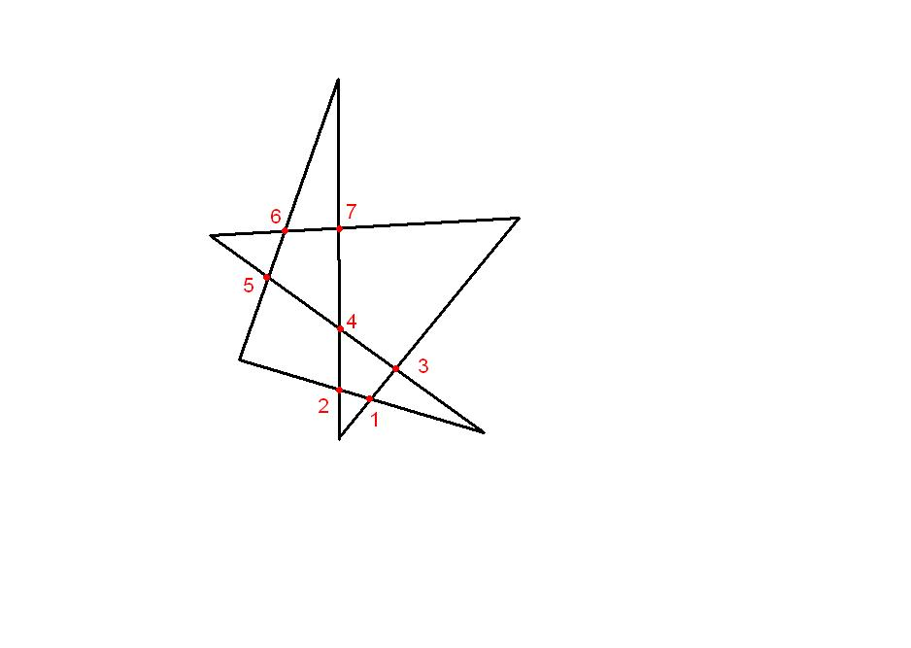
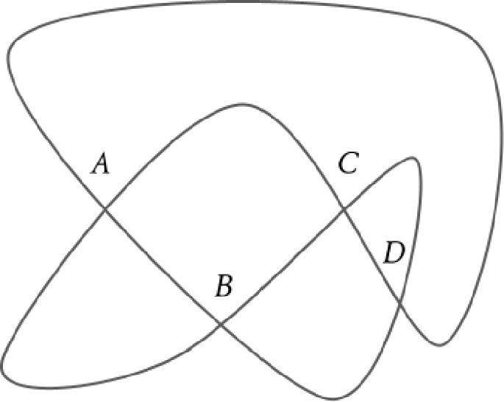
Example
$$\text{Line}→\text{Arc}→\text{Line}$$
where the final line crosses the first line.
There exists a point $P$reached at different portions of the path.

17. Open Composite Path
# Source: AI Source: Provided by: [Data Path: Persons Table -> ID Column: 1, Name_En Column: Motasem Essam] -> From: [ChatGPT] on [7/25/2026]
An Open Composite Path has different starting and ending points:
$$\boxed{P_{s}≠P_{e}}$$
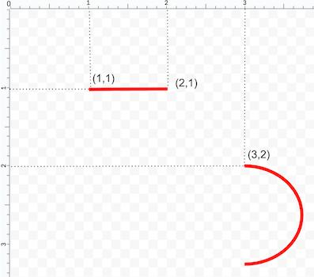
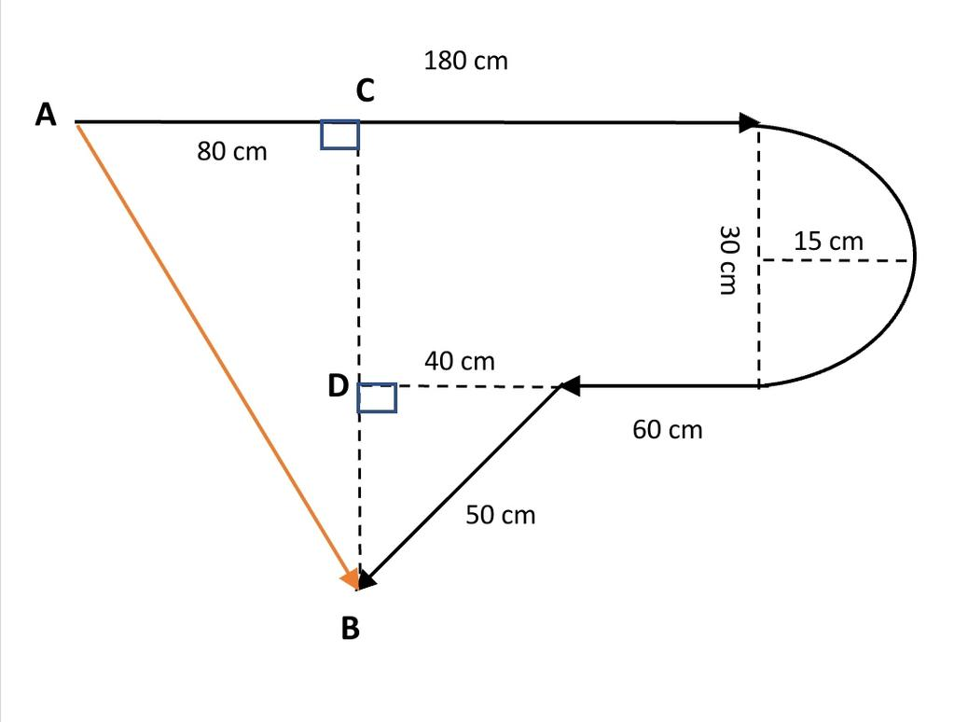
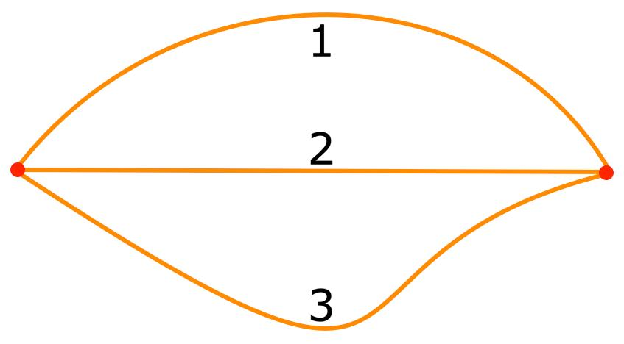
Example
$$A→\text{Straight}→\text{Arc}→\text{Straight}→B$$
where:
$$A≠B.$$

18. Closed Composite Path
# Source: AI Source: Provided by: [Data Path: Persons Table -> ID Column: 1, Name_En Column: Motasem Essam] -> From: [ChatGPT] on [7/25/2026]
A Closed Composite Path returns to its starting point:
$$\boxed{P_{s}=P_{e}}$$
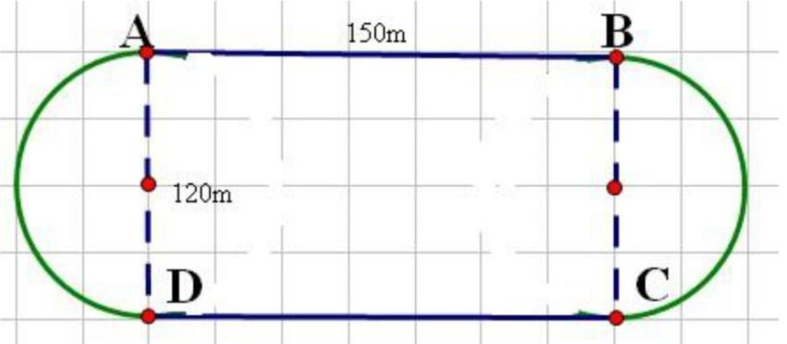
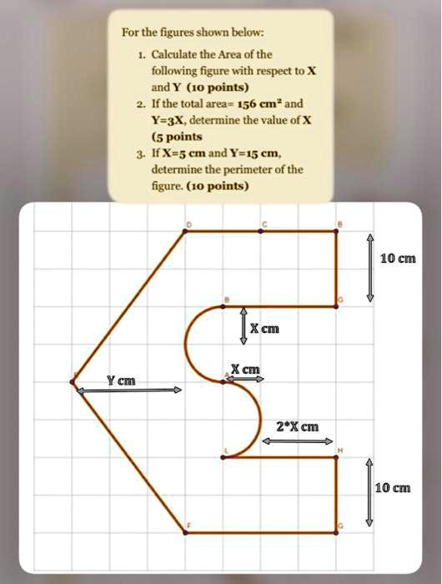
Example
$$\text{Line}→\text{Circular Arc}→\text{Line}→\text{Circular Arc}$$
returning to the original point.

19. Parametric Composite Path
# Source: AI Source: Provided by: [Data Path: Persons Table -> ID Column: 1, Name_En Column: Motasem Essam] -> From: [ChatGPT] on [7/25/2026]
A Parametric Composite Path uses different parametric equations for different portions.
$$r\left(t\right)=\left\{\begin{matrix}r_{1}\left(t\right), & t_{0}≤t≤t_{1} \\ r_{2}\left(t\right), & t_{1}≤t≤t_{2} \\ ⋮ & \\ r_{n}\left(t\right), & t_{n-1}≤t≤t_{n}\end{matrix}\right.$$
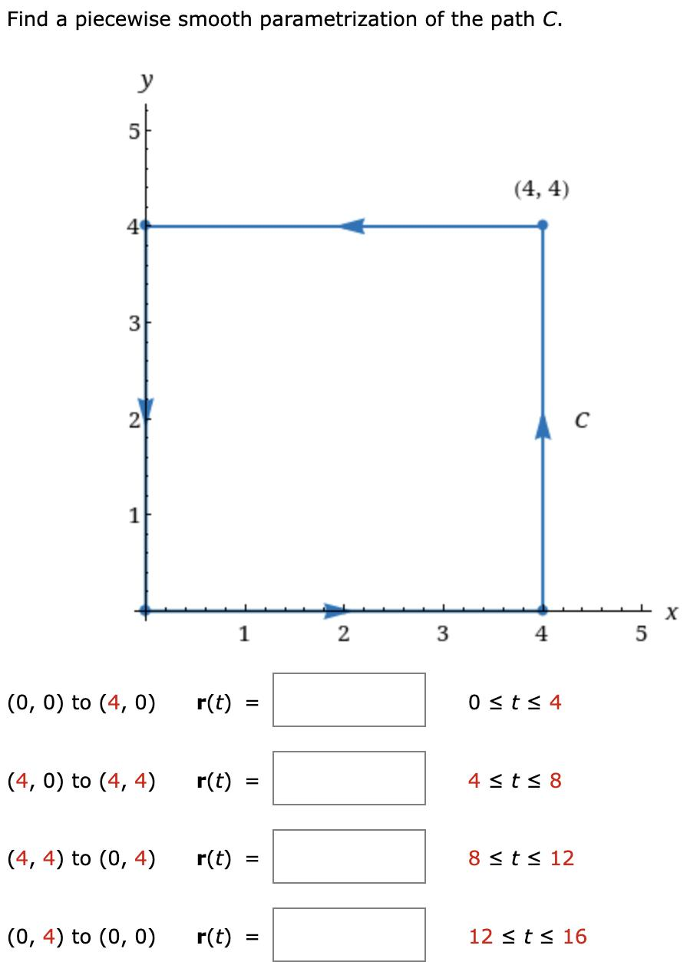
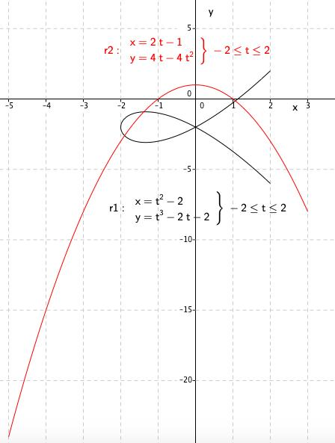
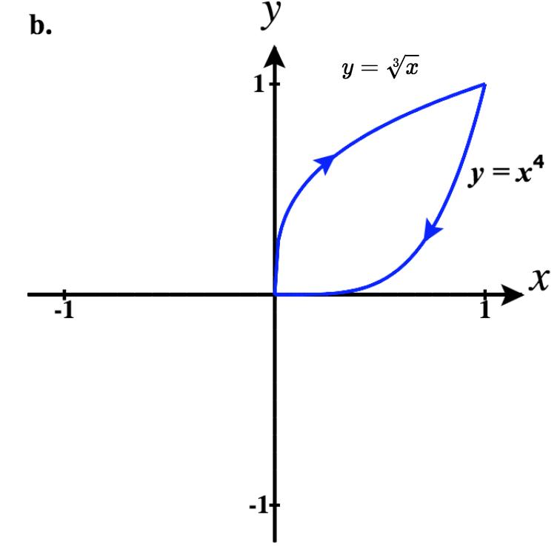
Example
$$r\left(t\right)=\left\{\begin{matrix}\left\langle t , 0\right\rangle , & 0≤t≤2 \\ \left\langle 2 , +\cos{t}\sin{t}\right\rangle , & 2≤t≤4\end{matrix}\right.$$
Each interval defines a different portion of the path.

20. Restricted Composite Path
# Source: AI Source: Provided by: [Data Path: Persons Table -> ID Column: 1, Name_En Column: Motasem Essam] -> From: [ChatGPT] on [7/25/2026]
A Restricted Composite Path is a composite path subject to additional restrictions.
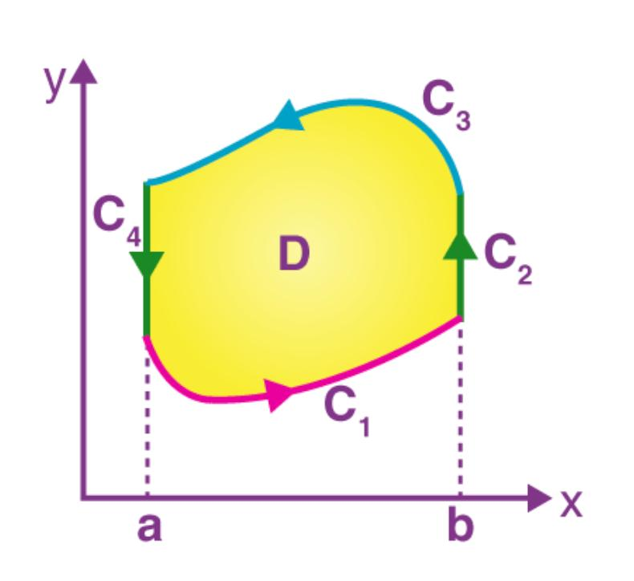
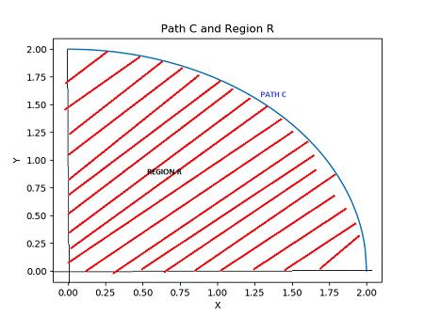
Restrictions may include:
$$x≥0 \\ 0≤t≤5$$
or:
$$P∈R.$$
Example
A line–arc–line path may be restricted to remain inside a rectangular region.

General Mathematical Representation
# Source: AI Source: Provided by: [Data Path: Persons Table -> ID Column: 1, Name_En Column: Motasem Essam] -> From: [ChatGPT] on [7/25/2026]
A composite path can be represented as:
$$\boxed{P=P_{1}∪P_{2}∪⋯∪P_{n}}$$
with:
$$n≥2.$$
For connected pieces:
$$\boxed{P_{i}∩P_{i+1}=\left\{V_{i}\right\}}$$
for a single-point connection.
A piecewise parameterization can be written:
$$\boxed{r\left(t\right)=\left\{\begin{matrix}r_{1}\left(t\right), & t_{0}≤t≤t_{1}, \\ r_{2}\left(t\right), & t_{1}≤t≤t_{2}, \\ ⋯ & \\ r_{n}\left(t\right), & t_{n-1}≤t≤t_{n}.\end{matrix}\right.}$$

Length of a Composite Path
# Source: AI Source: Provided by: [Data Path: Persons Table -> ID Column: 1, Name_En Column: Motasem Essam] -> From: [ChatGPT] on [7/25/2026]
The total path length is the sum of the lengths of all pieces:
$$\boxed{L=L_{1}+L_{2}+⋯+L_{n}}$$
or:
$$\boxed{L=\sum_{i=1}^{n}{L_{i}}}$$
For example:
$$L=L_{\text{line}}+L_{\text{arc}}+L_{\text{line}}.$$
For a circular arc:
$$L_{\text{arc}}=rθ$$
when $θ$is in radians.

Composite Path Example
# Source: AI Source: Provided by: [Data Path: Persons Table -> ID Column: 1, Name_En Column: Motasem Essam] -> From: [ChatGPT] on [7/25/2026]
Consider:
$$A→B→\text{Circular Arc}→C→D$$
The path contains:
- straight segment $AB$
- circular arc
- straight segment $CD$
Therefore:
$$\boxed{P=P_{1}∪P_{2}∪P_{3}}$$
and:
$$\boxed{L=L_{1}+L_{2}+L_{3}}$$
If the pieces connect without gaps, the path is continuous.
If their tangent directions also match at the junctions, it is smooth.

Composite Path vs Piecewise Path
# Source: AI Source: Provided by: [Data Path: Persons Table -> ID Column: 1, Name_En Column: Motasem Essam] -> From: [ChatGPT] on [7/25/2026]
These concepts are extremely closely related.
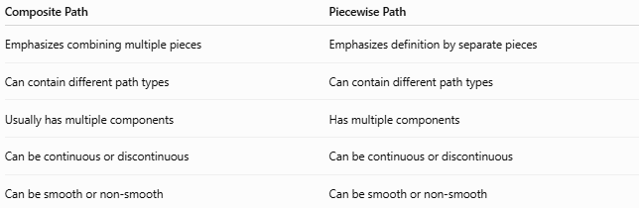
Composite Path | Piecewise Path
Emphasizes combining multiple pieces | Emphasizes definition by separate pieces
Can contain different path types | Can contain different path types
Usually has multiple components | Has multiple components
Can be continuous or discontinuous | Can be continuous or discontinuous
Can be smooth or non-smooth | Can be smooth or non-smooth
In many geometric contexts:
$$\boxed{\text{Composite Path}≈\text{Piecewise Path}}$$
The terminology is not completely universal; composite emphasizes the combination, while piecewise emphasizes the separate rules used on different portions.

Composite Path vs Polygonal Path
# Source: AI Source: Provided by: [Data Path: Persons Table -> ID Column: 1, Name_En Column: Motasem Essam] -> From: [ChatGPT] on [7/25/2026]
A polygonal path is a special case of a composite path when all pieces are straight segments.
$$\boxed{\text{Polygonal Path}⊂\text{Composite Path}}$$
if “composite” is being used in the broad sense of a path assembled from multiple pieces.

Composite Path vs Simple Path
# Source: AI Source: Provided by: [Data Path: Persons Table -> ID Column: 1, Name_En Column: Motasem Essam] -> From: [ChatGPT] on [7/25/2026]
These classify different properties.
Composite describes the path's composition.
Simple describes its self-intersection.
Therefore, a path can be:
$$\boxed{\text{Simple Composite Path}}$$
or:
$$\boxed{\text{Self-Intersecting Composite Path}}$$

Composite Path vs Open/Closed Path
# Source: AI Source: Provided by: [Data Path: Persons Table -> ID Column: 1, Name_En Column: Motasem Essam] -> From: [ChatGPT] on [7/25/2026]
Open and closed describe the endpoints.

Composite Path
├── Open Composite Path
└── Closed Composite Path
Thus:
$$P_{s}≠P_{e}$$
means open, while:
$$P_{s}=P_{e}$$
means closed.

Classification Summary
# Source: AI Source: Provided by: [Data Path: Persons Table -> ID Column: 1, Name_En Column: Motasem Essam] -> From: [ChatGPT] on [7/25/2026]
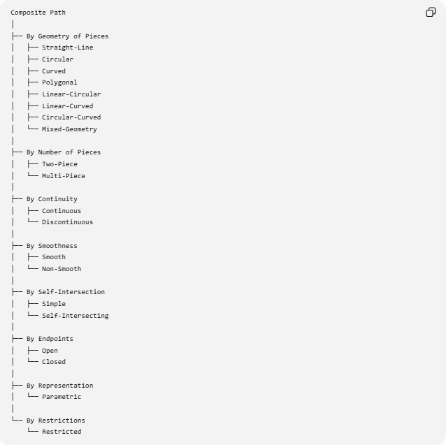
Composite Path
│
├── By Geometry of Pieces
│ ├── Straight-Line
│ ├── Circular
│ ├── Curved
│ ├── Polygonal
│ ├── Linear-Circular
│ ├── Linear-Curved
│ ├── Circular-Curved
│ └── Mixed-Geometry
│
├── By Number of Pieces
│ ├── Two-Piece
│ └── Multi-Piece
│
├── By Continuity
│ ├── Continuous
│ └── Discontinuous
│
├── By Smoothness
│ ├── Smooth
│ └── Non-Smooth
│
├── By Self-Intersection
│ ├── Simple
│ └── Self-Intersecting
│
├── By Endpoints
│ ├── Open
│ └── Closed
│
├── By Representation
│ └── Parametric
│
└── By Restrictions
└── Restricted

Key Formulas
# Source: AI Source: Provided by: [Data Path: Persons Table -> ID Column: 1, Name_En Column: Motasem Essam] -> From: [ChatGPT] on [7/25/2026]
Composite Structure
$$\boxed{P=\bigcup_{i=1}^{n}{P_{i}}}$$
Connected Pieces
$$\boxed{P_{i}∩P_{i+1}=\left\{V_{i}\right\}}$$
Total Length
$$\boxed{L=\sum_{i=1}^{n}{L_{i}}}$$
Circular Piece
$$\boxed{s=rθ}$$
Straight-Line Piece
$$\boxed{AB=\sqrt{{\left(x_{B}-x_{A}\right)}^{2}+{\left(y_{B}-y_{A}\right)}^{2}}}$$
Continuous Junction
$$\boxed{P_{i}\left(t_{i}\right)=P_{i+1}\left(t_{i}\right)}$$
Smooth Junction
$$\boxed{T_{i}\left(V_{i}\right)=T_{i+1}\left(V_{i}\right)}$$
Open Composite Path
$$\boxed{P_{s}≠P_{e}}$$
Closed Composite Path
$$\boxed{P_{s}=P_{e}}$$

Key Points
# Source: AI Source: Provided by: [Data Path: Persons Table -> ID Column: 1, Name_En Column: Motasem Essam] -> From: [ChatGPT] on [7/25/2026]
- A Composite Path combines two or more path pieces.
- The pieces may have the same or different geometric forms.
- It can combine straight segments, circular arcs, and other curves.
- A composite path can be open or closed.
- It can be simple or self-intersecting.
- It can be continuous or discontinuous.
- It can be smooth or non-smooth.
- Its total length is the sum of the lengths of its pieces:
$$L=\sum{L_{i}}.$$
- A polygonal path can be viewed as a composite path made entirely from straight segments.
- A line–arc–line path is a common composite structure.
- Composite and piecewise paths are closely related, although the terminology emphasizes different aspects.
- Composite paths are useful for representing realistic trajectories that cannot be described by one simple geometric curve.

Conclusion
# Source: AI Source: Provided by: [Data Path: Persons Table -> ID Column: 1, Name_En Column: Motasem Essam] -> From: [ChatGPT] on [7/25/2026]
A Composite Path is a geometric path constructed by joining multiple path pieces into one overall path:
$$\boxed{P=P_{1}∪P_{2}∪⋯∪P_{n}, n≥2}$$
The pieces may be straight, circular, curved, polygonal, or mixed.
Its most important classifications are based on:
- geometry of pieces
- number of pieces
- continuity
- smoothness
- self-intersection
- open/closed structure
- mathematical representation
- restrictions
The fundamental idea is:
$$\boxed{\text{Composite Path}=\text{Multiple Geometric Path Pieces Combined Together}}$$
and its length is:
$$\boxed{L=L_{1}+L_{2}+⋯+L_{n}}$$
making composite paths especially useful in geometry, computational geometry, engineering, transportation, robotics, computer graphics, and motion planning.

